The Official Journal of the Colorado Springs Rocket Society (COSROCS)


NAR Section #515

2002 LAC Award Winner!

Volume 16, Issue 1-6 January-December 2005

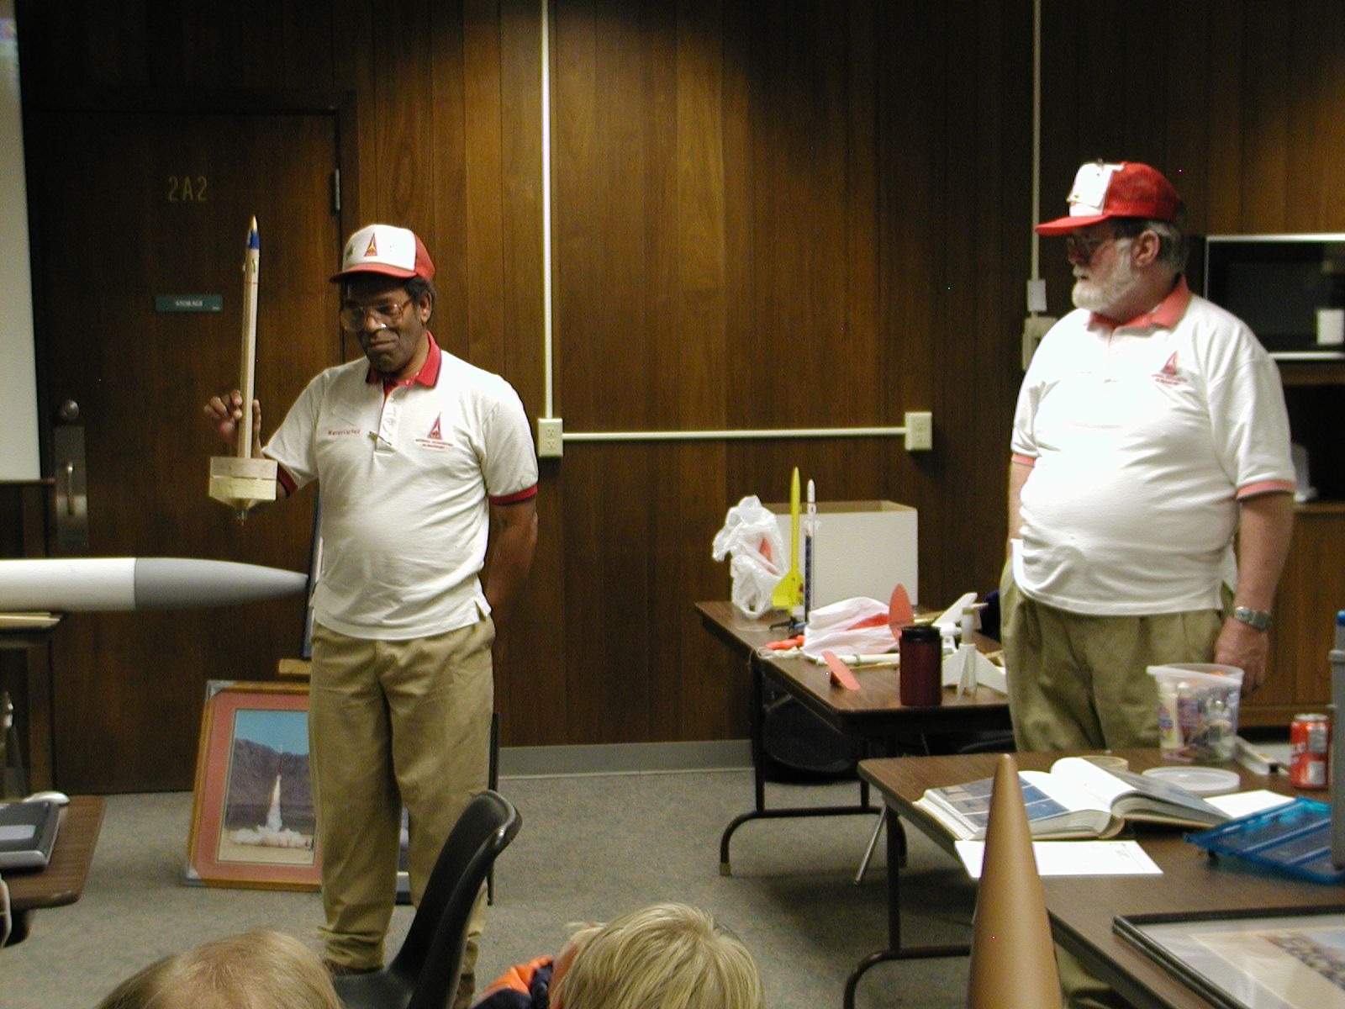
Inside this issue:
Page

The Nagging Editor 3
The President Speaks! 3
Section News 3
County Fair Display a Success 3
NASA The Space Place 3-4
COSROCS Items for Sale 4
Dr Warren article 4
Peyton/Challenger Launch Logs May - Oct 04 4-5
4H Rocket Seminar Photos Jan 2005 6
More Launch Photos from 2005 7
COSROCS 2004 Calendar 10
Photos Page 11
“This is a rocket…”
Dr Warren gets technical
at the 4H rocketry seminar,
15 Jan 2005.
Photo courtesy the Dave Virga archives.

Disclaimer: Most of the inputs for this issue were received in email form. Some of the launch logs were compiled from handwritten cards and logs, and were hard to read as a result. The editor did his best to decipher them and apologizes for any inadvertent errors.

COSROCS Officers (2005)

President: Dave Virga, virga@datawest.net
Vice President: Neil Kinney, nkinney@aecom-sig.com
Section Advisor: Warren Layfield, section515@juno.com
Secretary: Nadine Kinney, photos.by.nadine@pcisys.net
Treasurer: Mark James, markjames@pcisys.net
Librarian: Dave Virga, virga@datawest.net
Contests: Dave Nauer, david.nauer@wcom.com
Web Master: Mark James, markjames@pcisys.net

The COS-Rocketeer

Volume 16, Number 1-6
January-December 2005

The COS-Rocketeer is the official journal of the Colorado Springs Rocket Society (COSROCS), NAR section #515. This journal, published bi-monthly by members of COSROCS, serves to provide information on all aspects of rocketry. Articles, rocket plans, and photos are always welcome. Items for publication should be submitted to the editor:

Tom Dembowski
2385 Thornhill Dr
Colorado Springs, CO 80920

e-mail: TomDco@msn.com

Material appearing in The COS-Rocketeer may be reprinted by Sport Rocketry magazine or other NAR section newsletters, as long as proper credit is given.

COSROCS’ membership dues are $20.00 per year per family. Junior memberships (under age 18) cost $5.00 per year. Checks should be made payable to COSROCS. Applications and payment should be mailed to the following address:

COSROCS
P.O. Box 15896
Colorado Springs, CO 80935-5896

The COSROCS phone number is (719)575-0060

If you have access to the Internet, COSROCS has a web site and a listserv. The COSROCS web site is:
http://www.cosrocs.org.

The e-mail address for the listserv is cosrocs@yahoogroups.com. To subscribe to the listserv, go to http://www.yahoogroups.com to register and select COSROCS.

COSROCS is a family-oriented club. Everyone is always welcome at our launches and meetings. Please join us. You’ll have a blast!

COSROCS received the NAR’s LAC Award (Rockwell Trophy) in 2000 and 2002 for having produced the best NAR Section newsletter.

Launches and Meetings

COSROCS holds a business meeting on the second Wednesday of every month from 7:00PM until 9:00PM. The meeting location is the Gold Hills Police Station at 705 South Nevada Ave., Colorado Springs.

COSROCS holds a sport launch on the second Saturday of each month, weather permitting. The launch is held at the Challenger Middle School, located at Lexington Blvd. in Colorado Springs. The launches begin at 9:00AM and last until approximately 12:00 noon. Our launches are free and open to the public. A one pound weight limit is imposed for rockets launched at Challenger.
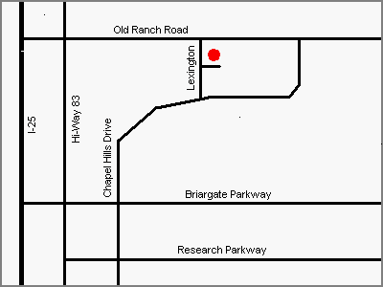

COSROCS holds a sport launch on the fourth Saturday of each month at Cape Preble in Peyton, Colorado. The launches begin at 9:00AM. This launch site has a 3.3 pound weight limit for rockets. To get to this launch site, head east on Hwy 24 towards Peyton. Turn left on Peyton Highway, right after the little grocery store. After the curve, bear right onto north bound Peyton Hwy. Drive to Sweet Road, 4th turn on the right. Go approx 2 1/4 miles on Sweet road. On the left, near the bottom of the hill, is a gate to the launch site (21410 Sweet Road). Look for the green ranch gate.

The Nagging Editor
By Tom Dembowski

I continue to ask for your help to have something to put in each issue. Whenever there is an event, please just shoot me a few lines and/or a picture to include. And please submit it in some sort of common file format (word etc). I have had excellent articles submitted in formats I (and others) could not open no matter how hard we tried. Keep it simple please.

Either way, I do appreciate all those who did send me articles to use in the newsletter. Thanks in advance for your help and keep those articles and pictures coming!

You will notice a definite lack of launch logs in this issue. All the ones I had were for 2004. Not sure if we did any in 2005 or they are merely misplaced. If Warren or I can locate them, we will publish them in future issues.

Update to the 2004 newsletter: You’d think I’d get it right after two years but…here are the names to go with the group picture on the cover of that edition (thanks again, Nadine):

Front row - left side: Sharron Mott, Will Miller
Back row – Joe and Bernie Tighe, George, Tom, Rachel Mott, Mark, Warren, Jim Tighe, Brooke Erlanger, Beth and Chris Reed.
Front row – right side: Bill Mott (probable), Nadine

The President Speaks!
By Dave Virga, COSROCS President (2005)

DON'T FORGET - Club launches moving from the 1st & 3rd Sat, to the 2nd and 4th weekends starting January 2005!

Section News

COSROCS received very sad news on 28 September that our friend and competitor, Bruce Markielewski from the CRASH section in Denver, passed away unexpectedly the previous weekend. Our own Dave Nauer said it best: “For those who knew Bruce, you know he was one of the top NAR competitors in the country…Bruce cared about the sport of rocketry and always had time to give suggestions and help to the novice or expert…I found his humor, kindness, and expertise in a sport I loved to be a memory I will treasure.”
.
County Fair COSROCS display a success
By Leslie and Deanna Mann

I want to take a minute and thank everyone who participated yesterday at the County Fair with the COSROCS display. I spent the majority of my time with the various 4-H rocketry judging events, but whenever I looked over your way, you never seemed to lacking an audience or inquisitive visitors to your display. And what a display!!! You were even able to get the Maxi-Omega inside the building - very cool.

Our 4-H Fly Day was a success sending three champions on to State Fair competition. We had seven participants in the event. Our results were 3 Champions (Juniors Unit 1 & 2, and a Senior, Unit 3), 2 Reserve Champions (Juniors Unit 1 and 2) and a Blue in Unit 1. We had one other member in Unit 2 who received a participation ribbon. He had a sudden emergency medical condition and was unable to complete the event. He was able to return later in the afternoon to the fair
grounds to participate in his interview judging, and seemed to have recovered from his ordeal completely. Thank you, George, for also attending our Fly Day event and for
providing assistance as needed. It got pretty windy at the end, but we were very fortunate that no rockets landed on the very busy road, and all came back with no or very minor damage.

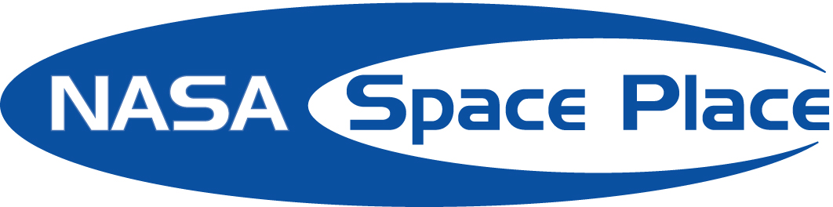

Submitted by Warren Layfield

Even Solar Sails Need a Mast
by Patrick L. Barry

Like the explorers of centuries past who set sail for new lands, humans may someday sail across deep space to visit other stars. Only it won't be wind pushing their sails, but the slight pressure of sunlight.

Solar sails, as they're called, hold great promise for providing propulsion in space without the need for heavy propellant. But building a solar sail will be hard; to make the most of sunlight's tiny push, the sail must be as large as several football fields, yet weigh next to nothing. Creating a super-lightweight material for the sail itself is tricky enough, but how do you build a “mast” for that sail that's equally light and strong?

Enter SAILMAST, a program to build and test-fly a mast light enough for future solar sails. With support from NASA’s In-Space Propulsion Program to mature the technology and perform ground demonstrator tests, SAILMAST’s engineers were ready to produce a truss suitable for validation in space that's 40 meters (about 130 feet) long, yet weighs only 1.4 kilograms (about 3 pounds)!

In spite of its light weight, this truss is surprisingly rigid. “It's a revelation when people come in and actually play with one of the demo versions—it’s like, whoa, this is really strong!” says Michael McEachen, principal investigator for SAILMAST at ATK Space Systems in Goleta, California.

SAILMAST will fly aboard NASA's Space Technology 8 (ST8) mission, scheduled to launch in February 2009. The mission is part of NASA’s New Millennium Program, which flight tests cutting-edge technologies so that they can be used reliably for future space exploration. While actually flying to nearby stars is probably decades away, solar sails may come in handy close to home. Engineers are eyeing this technology for “solar sentinels,” spacecraft that orbit the Sun to provide early warning of solar flares.

Once in space, ST8 will slowly deploy SAILMAST by uncoiling it. The truss consists of three very thin, 40-meter-long rods connected by short cross-members. The engineers used high-strength graphite for these structural members so that they could make them very thin and light.

The key question is how straight SAILMAST will be after it deploys in space. The smaller the curve of the mast the more load it can support. “That's really why we need to fly it in space, to see how straight it is when it's floating weightlessly,” McEachen says.

It’s an important step toward building a sail for the space-mariners of the future.

Find out more about SAILMAST at nmp.nasa.gov/st8. Kids can visit spaceplace.nasa.gov/en/kids/st8/sailmast to see how SAILMAST is like a Slinky® toy in space.

This article was provided by the Jet Propulsion Laboratory, California Institute of Technology, under a contract with the National Aeronautics and Space Administration.

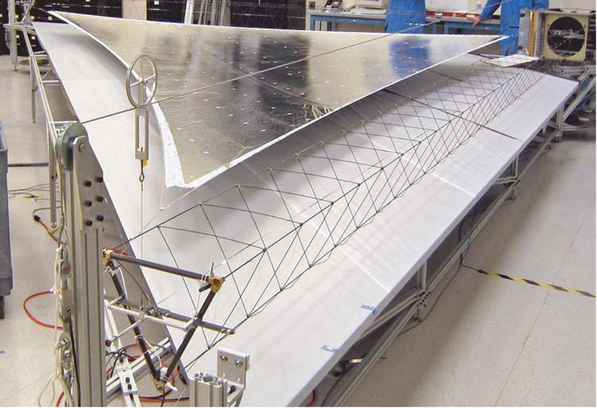

SAILMAST is the thin triangular truss in front of the picture. It is attached to a section of a silver foil solar sail section shown here in a laboratory test. The mast in the picture is 2m (6 ft) long. The Space Technology 8 mission will test the SAILMAST, which is 20 times longer.

COSROCS Items for Sale

COSROCS Pins. The COSROCS pins are on sale. They look great. The pins have the COSROCS logo and a 1, 2, or 3 on them to indicate your certification level. Pins without a certification level are also available. The cost per pin is $5. Contact Warren Layfield if you want to purchase one.

ASTRONAUT CHALLENGES FOX MEADOW
STUDENTS TO EMBRACE THE DESTINY
OF THEIR GENERATION
Submitted by Dr Warren Layfield

United States Astronaut Captain Jeffrey Ashby sent a strong message to the students of Fox Meadow Middle School during the NASA Explorer Program kick-off assembly on October 20:

"We're going to Mars and you guys are going to take us there."

Capt. Ashby told the students and staff that Earth is highly at risk of an astronomical collision in the future -- similar to the one that made dinosaurs extinct. Mankind's survival will depend on the ability to live on another planet, he said. NASA has already begun preparations for life on Mars by joining 15 other countries in assembling the International Space Station so astronauts can learn to live in space for long stretches of time. By the time the Fox Meadow students are out of college, NASA astronauts will have a permanent presence on the moon.
That's where today's middle-school aged students come in -- as adults, they will be responsible for designing and building the space ship that will make the six-month trip to the "Red Planet."
"You need to study and you need to learn because one day, you will be the ones taking us to Mars," Capt. Ashby explained. "It's the destiny of your generation."
Capt. Ashby -- a graduate of Evergreen High School in Evergreen, Colorado -- has flown on three space missions. He piloted the Space Shuttle Columbia in 1999 and the Space Shuttle Endeavour in 2001. In 2002, he was the mission commander of Space Shuttle Atlantis. He has traveled more than 11 million miles, flown 436 orbits around Earth, and logged over 660 hours in space. He is currently on special assignment at Air Force Space Command in Colorado Springs.
Capt. Ashby was one of several special guests at the school-wide assembly celebrating Fox Meadow's launch of the NASA Explorer Program. Other guests included Vicki Kloeris, manager of Shuttle and ISS Food Systems at Johnson Space Center in Houston; NASA Education Specialist Susan Anderson, Carol O'Leary from the Challenger Learning Center; Rocket Mentor Dr. Warren Layfield; Amy McRae, Communication and Public Affairs Specialist for Honeywell Technology Solutions Inc.; HSD2 Superintendent Vic Meyers; HSD2 Parents and Board of Education Candidates Paul Lastrella and Linda Pugh; several HSD2 administrators; and various representatives from Intel, the University of Colorado at Colorado Springs, the Space Foundation, the Naval Observatory, the U.S. Air Force Academy, Analytical Graphics Inc., and Booz, Allen & Hamilton. Live music was provided by the Air Force Academy's "Wild Blue Country."
As co-guest speaker, Ms. Kloeris encouraged the students to take advantage of the Explorer Program. She spoke about how critical it is that students study math and science so they may help tackle a number of technological issues in the NASA program.
"There are plenty of opportunities for each of you to make a difference," she said.
Ms. McRae attended the event to show support on behalf of Honeywell. She said the company is eager to continue its neighborly relationship with the school. Honeywell supports school events, helps secure funding for school programs and sponsors teachers to attend the Honeywell Space Academy for Educators.
"We're cultivating our future engineers through the teachers and programs," she said.
Ms. McRae said Honeywell is hoping to bring "FMA Live!" to the school in the near future. FMA Live! is an innovative and dynamic stage show that uses live actors, music, video and demonstrations to engage middle-school students in the wonders of science, technology and math through Sir Isaac Newton?s Three Laws of Motion and the Universal Law of Gravity.
Last spring, Fox Meadow was the only school in Colorado and one of only 50 schools nationwide to be selected as a 2005 NASA Explorer School. The three-year program supplies innovative teaching resources and technology tools using NASA's unique content, experts and other resources to provide exciting learning experiences in science, math and technology.

Launch Reports Go Missing!

Your editor could not find any launch reports for the 2005 calendar year. Warren and I looked everywhere but either we didn’t retain any logs or the ones we had are lost. We spent the month trying to find them but since the issue is ready to go, we will go to press with it as is. If there are some logs out there and they do turn up, I will include them in a later issue.

Launch Schedule for CY 2004

Prebles Ranch 22 January

Prebles Ranch 3 April (Special)

Prebles Ranch 28 May

Challenger MS 11 June

Prebles Ranch 25 June

Challenger MS 9 July

Challenger MS 14 August

Prebles Ranch 27 August

Challenger MS 10 September

Challenger MS 8 October

Prebles Ranch 22 October

Prebles Ranch 10 December (Christmas Party)

Photos Page

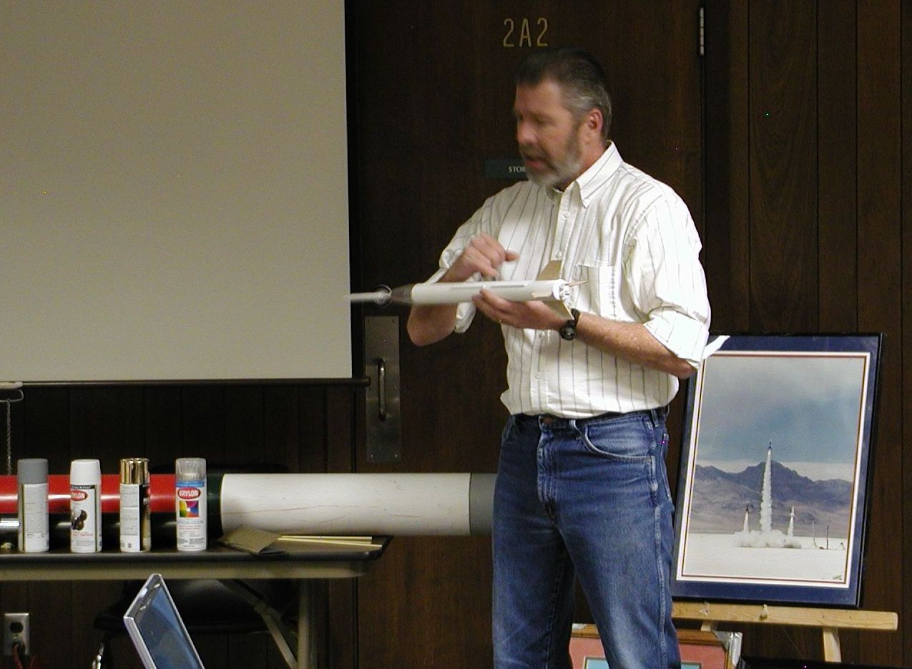

More from the 4H rocket seminar, 15 Jan 2005. (Photos by Dave Virga)

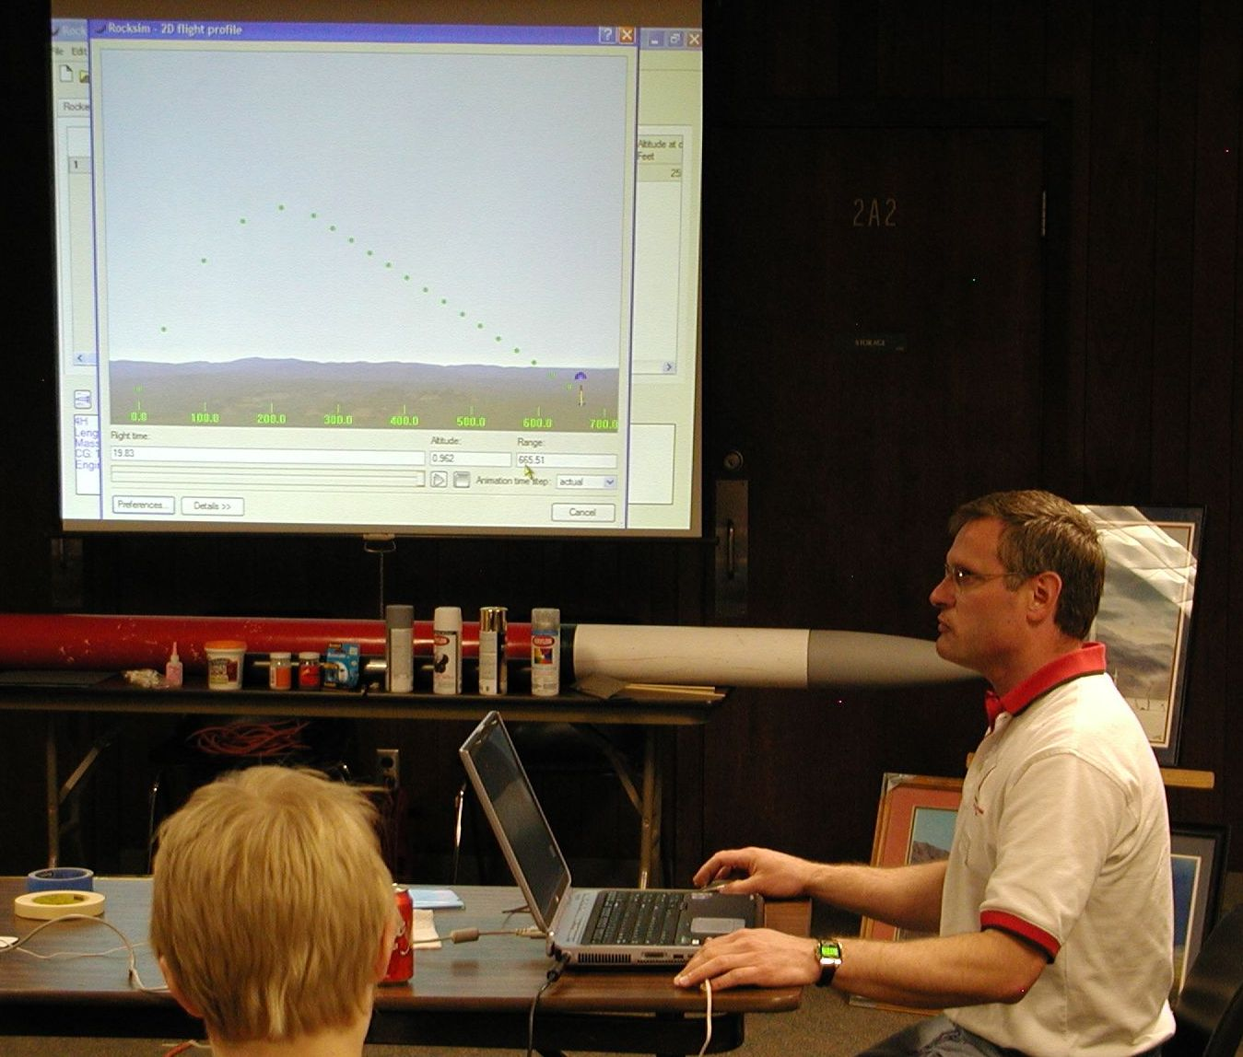
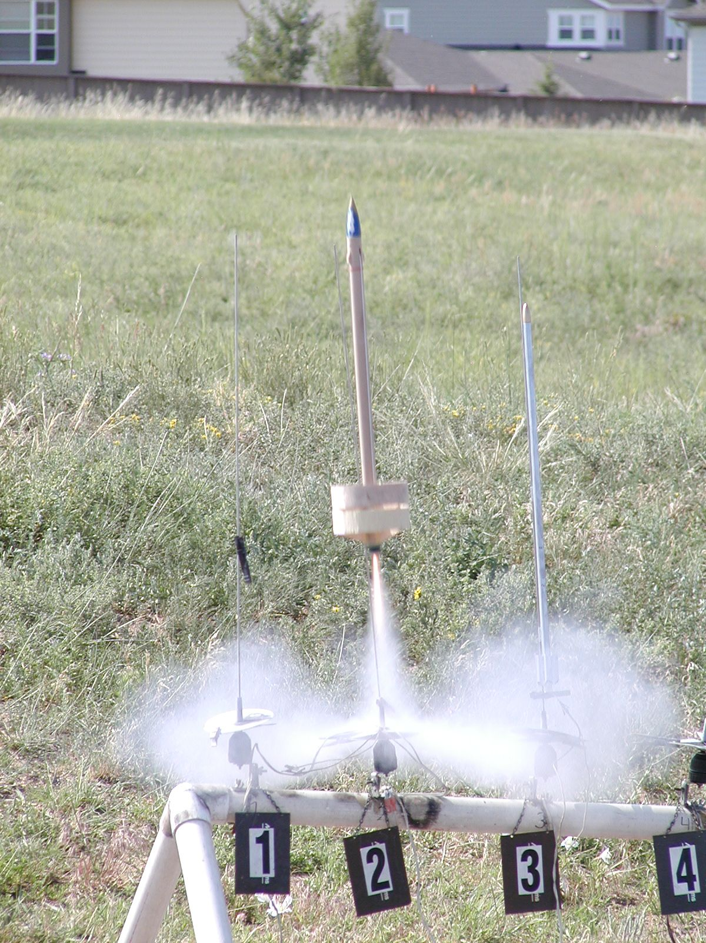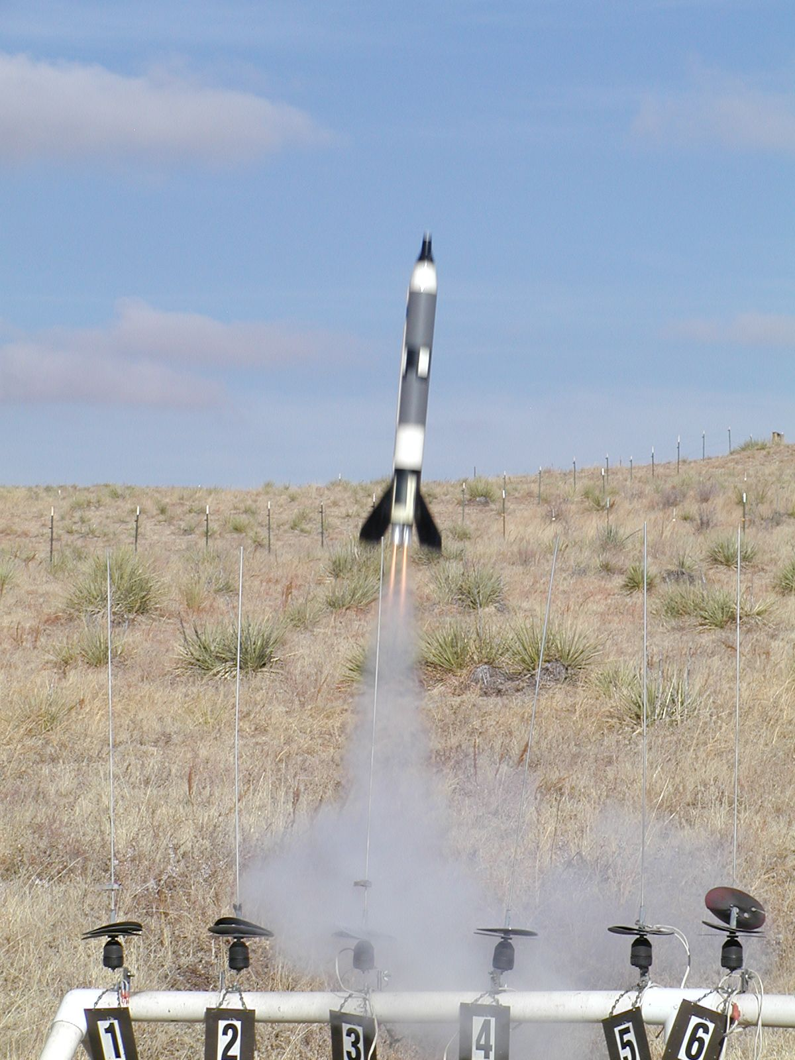

George Shaiffer’s Ringhawk lifts off at CMS,
9 Jul 2005.
(Photo from Virga Archives)
When was the last time you saw one of these? The editor’s original 1960’s era Gemini-Titan II, a two-engine cluster. (Photo from the Dave Virga archives)
(Photo from Virga archives)

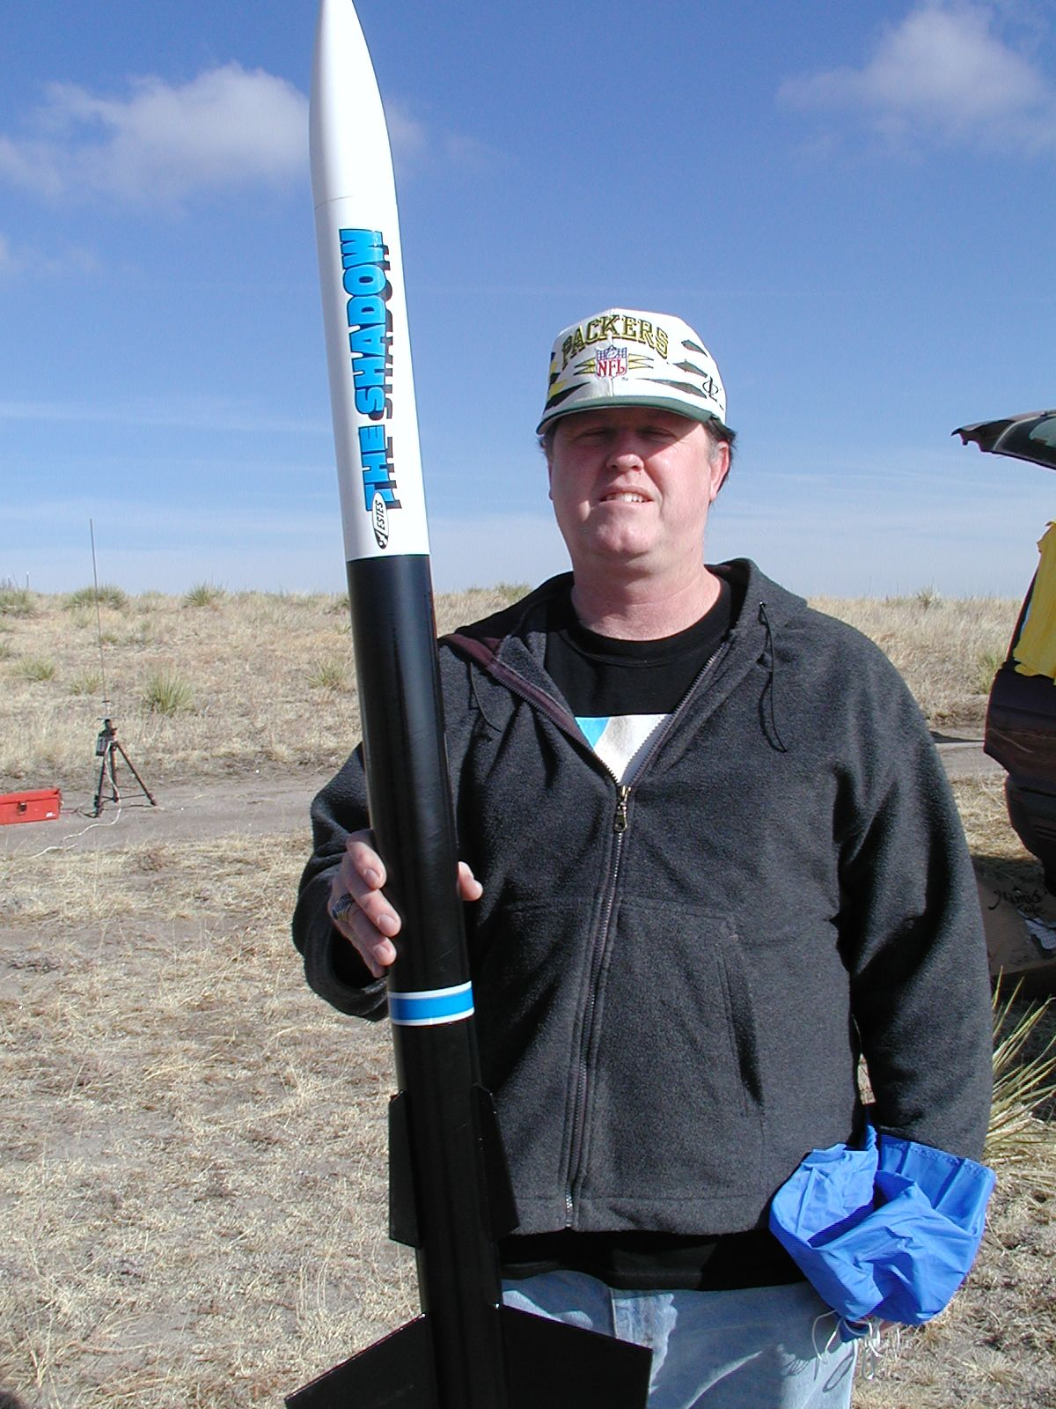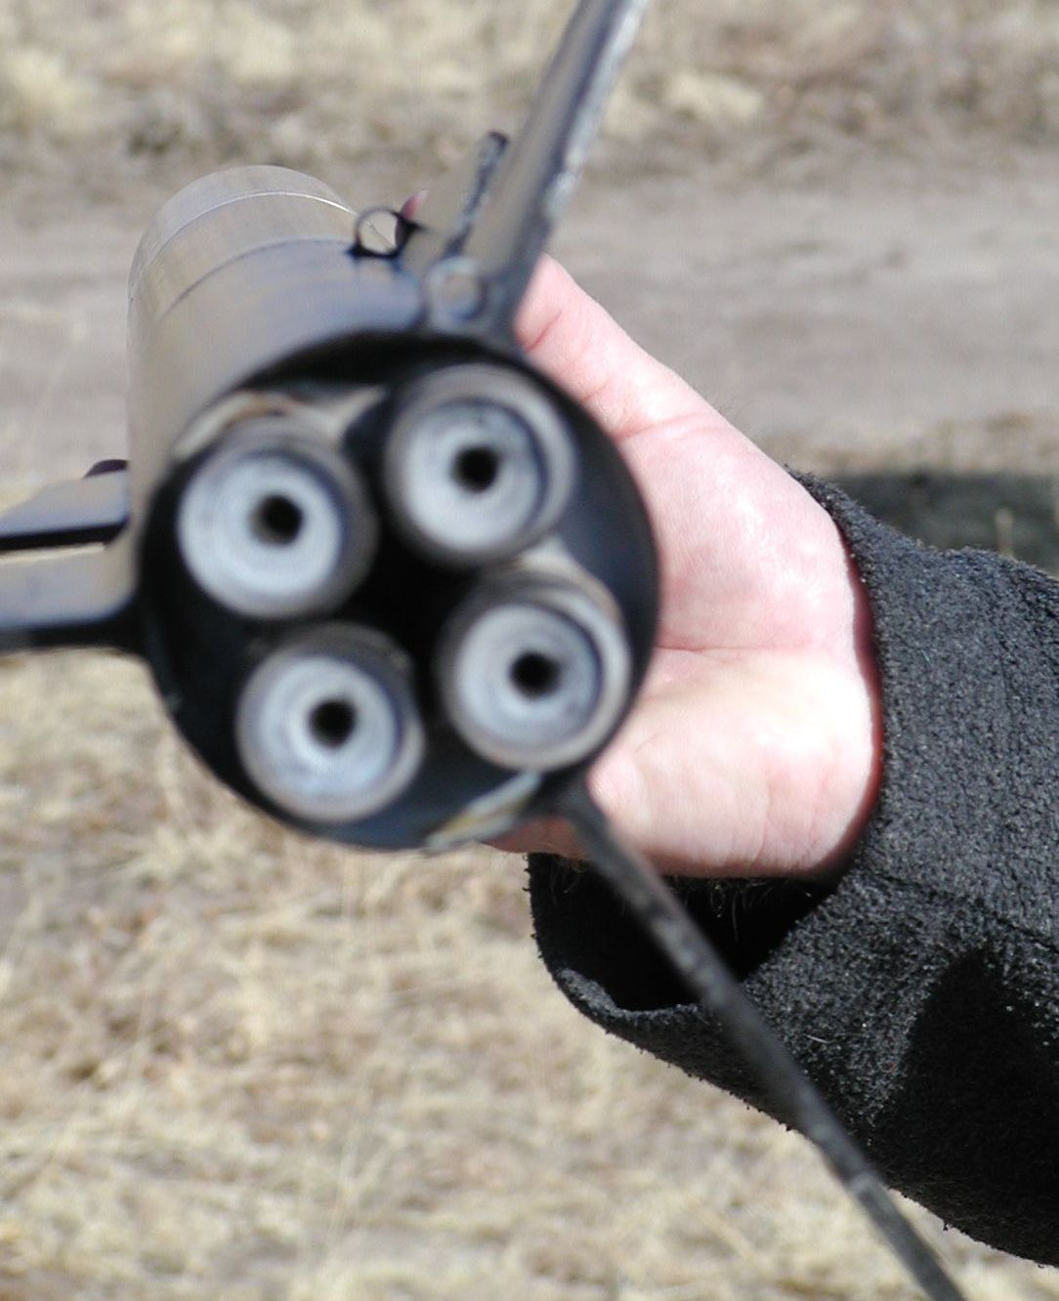
The Shadow knows…Greg Elder post-flilght, 22 Jan 2005.
(Photo by Dave Virga)
How a four engine cluster is supposed to work…Greg Elder’s Shadow.
(Photo by Dave Virga)

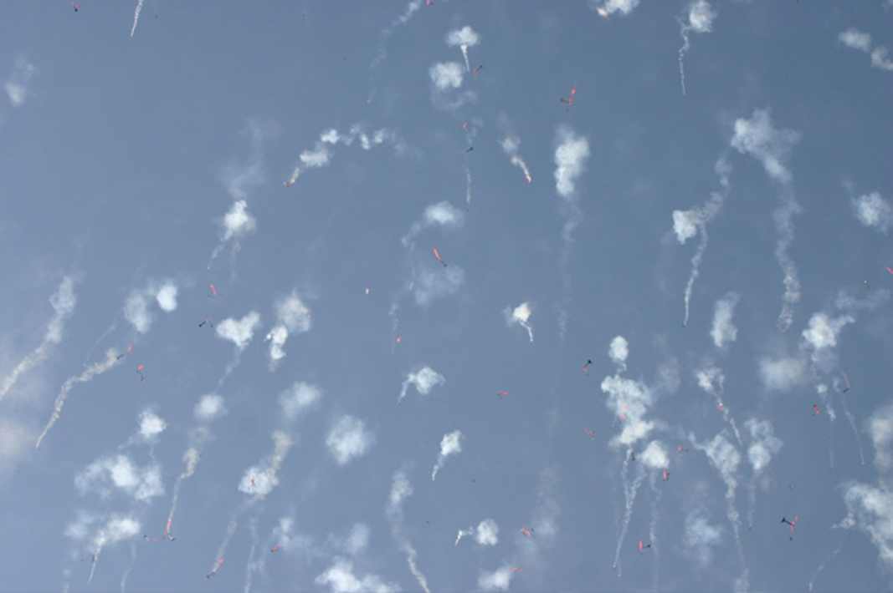
Sky rockets in flight…mass launch, somewhere in Nebraska, September 2005.
(Photo courtesy the Dave Virga archives)

COSROCS
P.O. Box 15896
Colorado Springs, CO 80935-5896

